
DeBeck Elementary School
8600 Ash St., Richmond BC V6Y 2S3
P. 604-668-6281 E: DeBeck@sd38.bc.ca
Website: debeck.sd38.bc.ca
Safe Arrival: 604-668-6272

Elevate Your Child's Education: Donate to Our Technology Upgrade Fundraiser

Dear DeBeck Families,

I hope this letter finds you and your loved ones in good health and high spirits. It's that time of year when we come together as a school community to support an important initiative that directly benefits our children's education. As a part of the DeBeck Parent Advisory Council (PAC), I am excited to kick-start our Technology Upgrade Fundraiser.

The goal of our Fundraiser is to raise $4,020 for technology upgrades (Throw Projectors and Apple TV) for 6 classrooms who did not receive them during the seismic upgrade. Between the school and the PAC, we are already able to fund the upgrades for 4 classrooms (totaling $8,040) and we hope to raise an additional $4,020 for the remaining 2 classrooms. Therefore, we greatly appreciate any amount you can contribute.

We kindly request your support in achieving our $4,020 fundraising goal. Your generous contributions will directly impact the learning experience of our children. Every dollar counts and brings us closer to our goal.

You can contribute to the fundraiser through SchoolCash Online: https://richmondsd38.schoolcashonline.com/Home/SignIn by April 17, 2026. Please follow the instructions attached. All donations over $20 will receive an official receipt for tax purposes via email.

If you have any questions or need further information, please do not hesitate to contact us by emailing debeckpac@gmail.com.

Thank you for your contributions to our Technology Upgrade Fundraiser. We appreciate your commitment to our school and your children's education.

Warm regards,
Tienne Schaub
PAC Chair

Instructions to Donate through SchoolCash Online

Step 1: Log on to SchoolCash Online https://richmondsd38.schoolcashonline.com/Home/SignIn


Step 2: Click on “ITEMS”

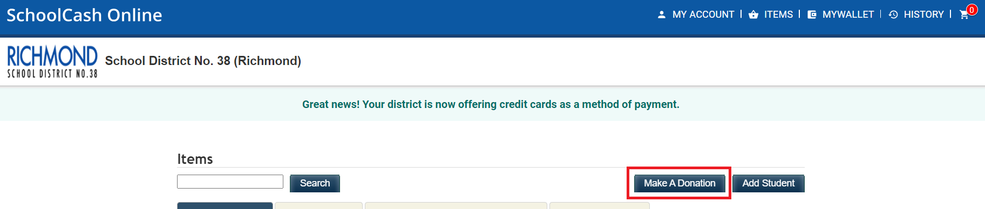
Step 3: Click on “Make a Donation”

Step 4:
- Select donation amount
- Select Fund Destination: “DeBeck Elementary”
- Input Message: “PAC iPad Fundraiser”
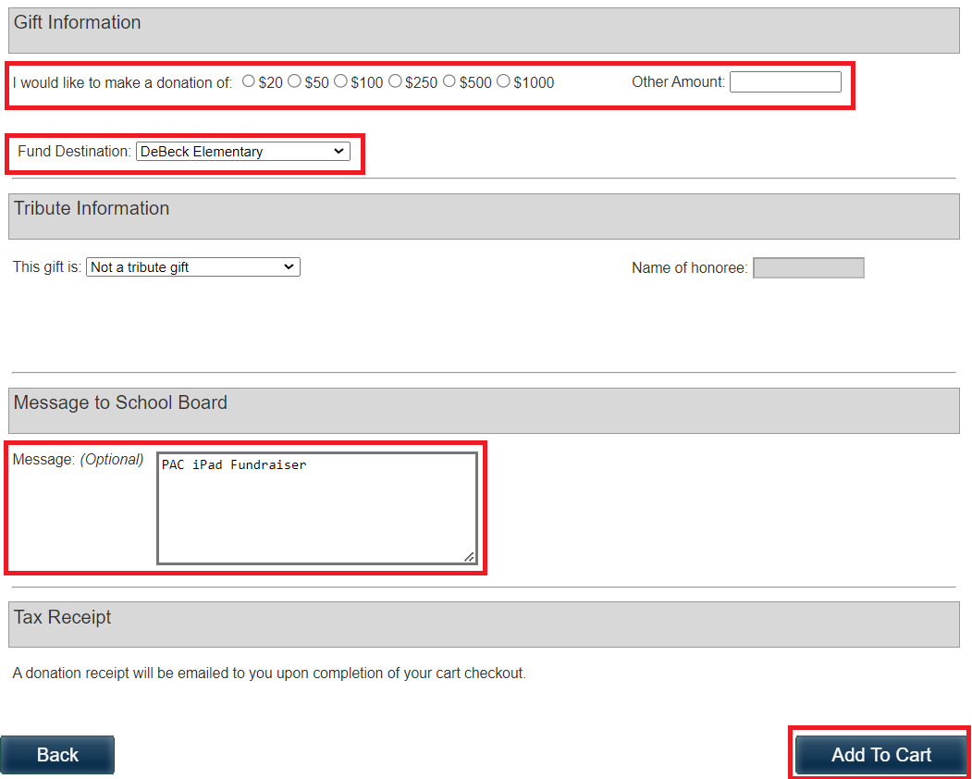
- Add To Cart and complete payment

