DeBeck School Spirit Wear 2025
Deadline to order is Thursday, November 6th, 2025

#ATCY2500 Youth Hoody (S – XL) #ATCF2500 Adult Hoody (S-2XL)

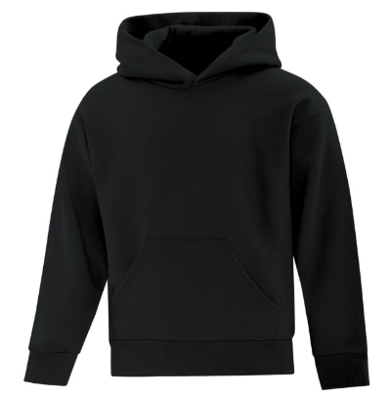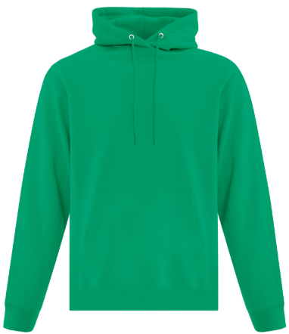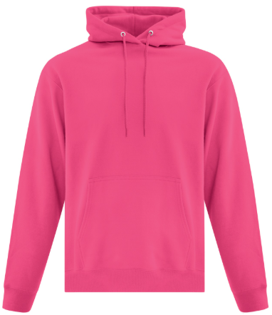
Black Kelly Green Pink (Sangria)
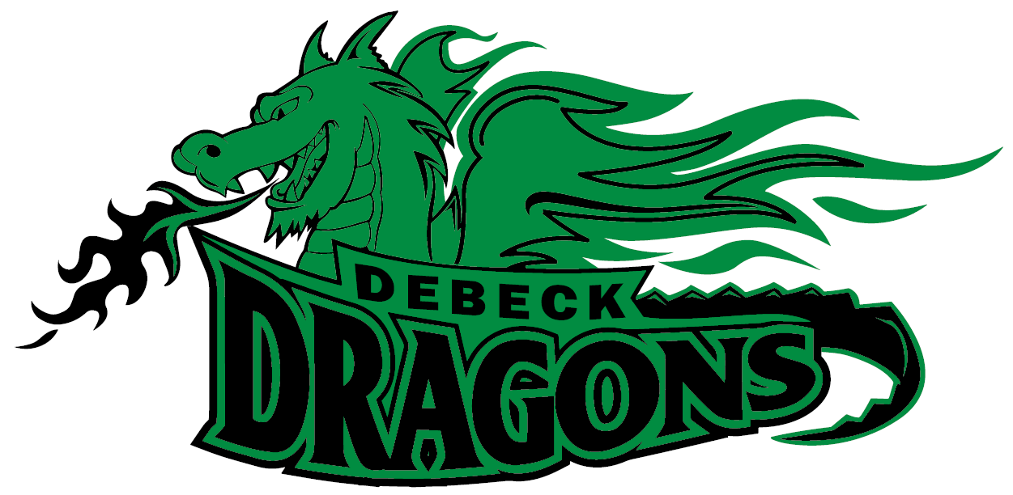

DeBeck Dragon Logo – Full Front – 2 Color Imprint
$37.00 each CAD

#800B Youth T-shirt (XS – XL) #8000 Adult T-shirt (S – 2XL)
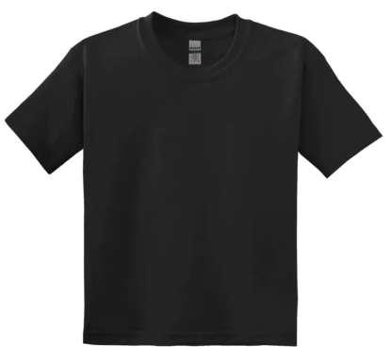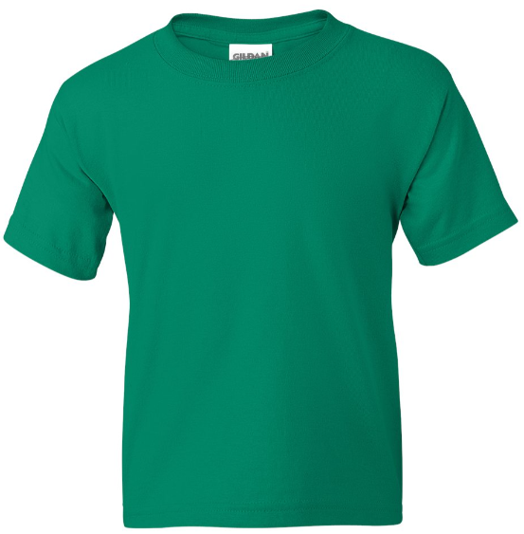
Black Kelly Green
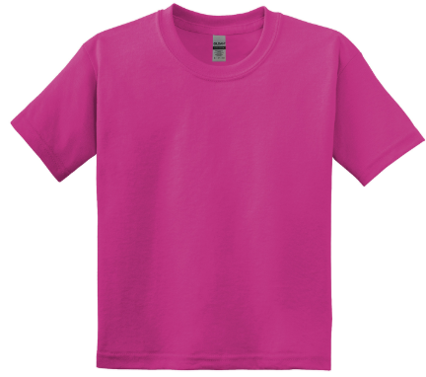
Pink (Heliconia)
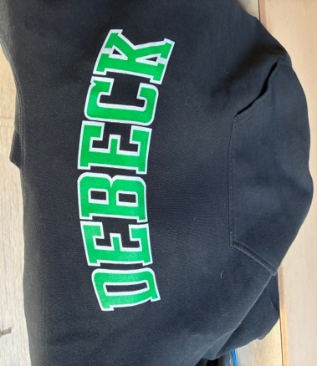
DeBeck Text Logo – Full Front – 2 Color Imprint
$14.00 each CAD

#Y350 Youth Dry Fit T-shirt (XS – XL) #S350 Adult Dry Fit T-shirt (XS – 2XL)
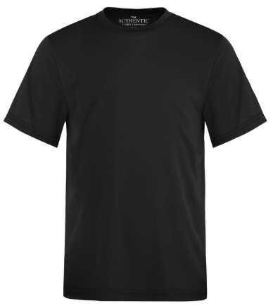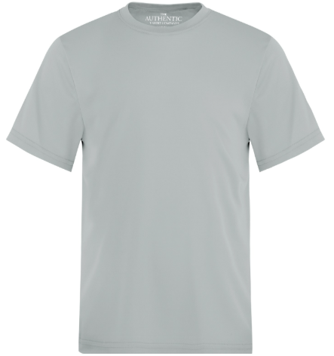
Black Silver Grey
DeBeck Dragon Logo – Full Front – 2 Color Imprint
$18.00 each CAD


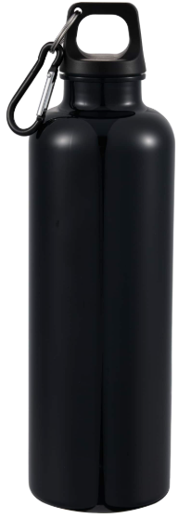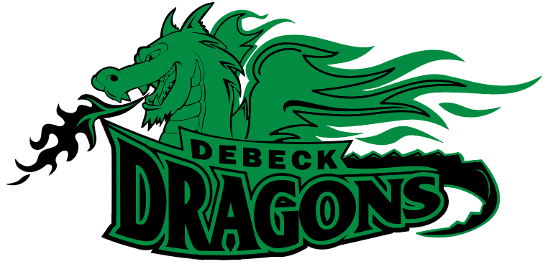
DeBeck Dragon Green Logo Printed on Bottle
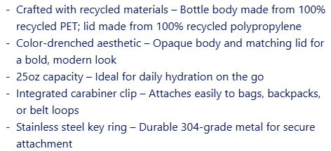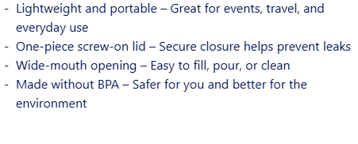

$10.00 each

