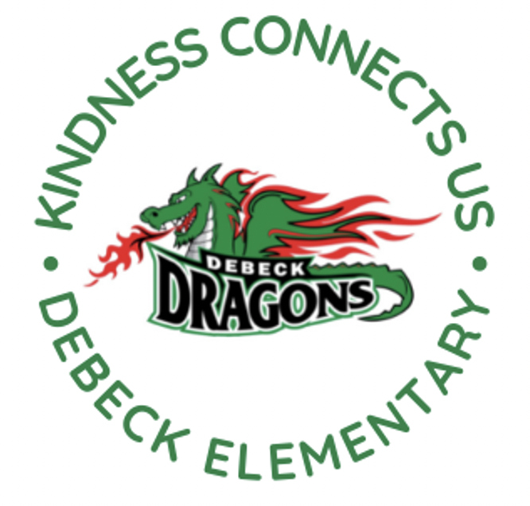
DeBeck Elementary School
8600 Ash St., Richmond BC V6Y 2S3
P. 604-668-6281 E: DeBeck@sd38.bc.ca
Website: debeck.sd38.bc.ca
Safe Arrival: 604-668-6272

L. Schwartz - Principal
C. Anderson – Vice Principal
________________________________________________________________________________________________________________

Week-At-A-Glance
April 1st-5th, 2024
Highlights For Next Week Include:

Monday | Easter Monday- No School
Tuesday | Welcome Back  Connection Crew- Student Leadership @ Lunch
Wednesday | Chess Club @ Lunch
Thursday

Friday

SCHOOL NEWS

Student Learning Survey 2024/2025

The Provincial Student Learning gathers information from parents/guardians/caregivers, teachers, and students on topics related to school environment, safety, and achievement. The information is used for planning in individual schools and provides a district and provincial perspective.

Early in 2024 the Student Learning Survey will be administered to students in grades 4 and 7. We encourage parents/guardians/caregivers to participate in this survey, as the results are important in identifying and celebrating current strengths, as well as determining where the school needs to focus improvement. The surveys contain standard questions for the province – in addition, questions from the school and/or district that focus on local conditions or issues may be included.

The survey can be completed electronically and can be accessed on the Internet at http://www.bced.gov.bc.ca/sat_survey. The survey can be accessed through the link without an anonymous logon code by selecting the school district and school name where your child attends school. Provincial, District and School Reports for previous years can be viewed at the same site under the Results section.

The e-survey site will be open until May 3rd.
If you have any questions, please contact the school at 604-668-6281

Term 2 Learning Update (Report Cards)-
In past years, Term 2 report cards have been sent home just before Spring Break. This year, the Richmond School District will be sending home report cards later in April. This will help create a balanced year for reporting as it extends term 2, which has been quite short in the past. Report Cards will go home to DeBeck families on Friday, April 26th this year.

Seismic Update-
The district maintains a Facilities Services website that updates seismic projects monthly. Please click here for more information about DeBeck’s seismic upgrade and other upgrades happening around the district. We learned today that the first four classes will be moving into the portables the second week of April. More details will be sent out after spring break.

PAC CORNER
Our PAC has opened up the last term of hot lunches from April to June. Place your orders by the end of March to ensure your children are included for April 8th. Orders can be placed online at http://www.munchalunch.com/schools/debeck.

DISTRICT NEWS

Early Learning for Families-
Do you have a 3 - 5-year-old preschooler? The Richmond School
District welcomes your family to the Early Learning for Families (ELFF) events. Join us for fun and engaging learning experiences while meeting new friends and building school connections.
It’s a great opportunity to ask questions all about Early Learning. Please see the attached poster for dates and locations.

CITY OF RICHMOND NEWS
The City of Richmond is offering some low-cost and free family-friendly events and activities (richmond.ca/SpringBreak over the upcoming Spring Break (Mar 15-Apr 1). Click the above link to browse events.

UPCOMING EVENTS

Mar. 15-April 1 Spring Break- School Not in Session

APRIL
8 PAC Hot Lunch: Pizza/Booster Juice
9 Fruit and Veggie Delivery (Apples)
12 Breakfast Club
15 PAC Hot Lunch: White Spot
18 Class Photos and Panorama
19 Cyber Presentation (Grade 6/7s in PM)
23 Fruit and Veggie Delivery (Cucumbers)
24 PAC Snack: Kernels
26 Term 2 Learning Updated (report cards) posted to MyEd
29 PAC Hot Lunch- Edo

