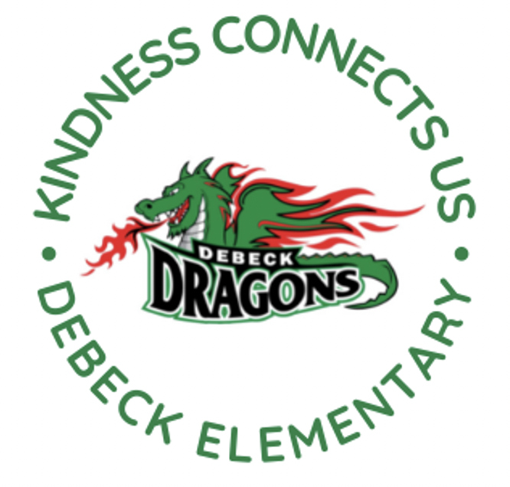
DeBeck Elementary School
8600 Ash St., Richmond BC V6Y 2S3
P. 604-668-6281 E: DeBeck@sd38.bc.ca
Website: debeck.sd38.bc.ca
Safe Arrival: 604-668-6272

L. Schwartz - Principal
C. Anderson – Vice Principal
________________________________________________________________________________________________________________

Week-At-A-Glance (WAAG) for Families:
Nov. 6 - Nov. 10 , 2023
Highlights For Next Week Include:

Monday | PAC Hot Lunch- Sushi
Tuesday | Grade 6/7 Volleyball (Away game at Garden City)
Wednesday | Volleyball Practice @ 7:45 AM
Thursday | Grade 6/7 Volleyball (Home game VS General Currie)  PAC Meeting
Friday | Remembrance Day Assembly
Remembrance Day Assembly- We have our Remembrance Day Assembly coming up on Friday, November 10th. In the past few years, DeBeck has grown. We now have a student population of 380 students. Unfortunately we are unable to fit all classes and families into the gym at one time. For this reason, we have decided to record our assembly and send it home in a secure, password protected link so that families are able to see their child’s performance. Please check your emails the week of November 13th for the link. The link will be available for viewing for two weeks.
Calling all Cadets, Girl Guides and Scouts- Debeck is looking for those students who participate in Girl Guides (Sparks, Brownies etc), Scouts or Cadets and would be interested in wearing their uniforms and helping us carry the flags into the Remembrance Day assembly (March on the Colours). Please email Mrs. Schwartz with your child’s name and division.
Breakfast Club- Our next Breakfast Club will be Friday, November 17th from 7:45 AM- 8:30 AM.
NOVEMBER Dates: November 17th and 24^{th.} (There will be no Breakfast Club on Friday, November 10th due to set up for our Remembrance Day Assembly.)
DECEMBER Dates: December 8th, 15th and 22nd (There will be no Breakfast Club on Friday, December 1st because it is a professional development day and there is no school for students.)
Thank you to our staff who cook, chop, set-up, serve and clean. Thank you to the parents who help the dishes and clean-up. Many hands make light work in this community endeavour.
We welcome any parents or caregivers to help with dishes and clean-up. Volunteer times are from 8:45 AM- 9:15 AM. If you are available please email Mrs. Schwartz lschwartz@sd38.bc.ca
Chess Club- Mr. Juric (school counsellor) has started a chess club for students in grade 4-7. Chess club happens at 12:10 in the Library on alternating Wednesdays (Nov. 1, 15 and 29). Thank you to Mr. Juric for providing this opportunity for our students.
Grade 6/7 Volleyball- Our grade 6/7 volleyball players continue to demonstrate teamwork and good sportsmanship at every game they play. We have also noticed an improvement in their game play. This would not be possible without the support of our coaches Ms. Adjei-Achampong, Ms. Kilby, Ms. Kim, Mr. Rymer and Ms. Tseng.
Book Fair- We are excited to share that the Fall Book fair is coming to DeBeck. Students will be given an opportunity to browse and an opportunity to buy during class time. There will also be Family book fair times before and after school on November 28th, 29th and 30th. Thank you Ms. Borthwick for organizing this event for our school. Money raised goes right back into our book collection for all of our students.
Seismic Upgrade- The district maintains a Facilities Services website that updates seismic projects monthly. Please click here for more information about DeBeck’s seismic upgrade and other upgrades happening around the district. We are still in the design phase and do not have a set start date.
HEALTH AND SAFETY and LEARNING TIP
Recently Mrs. Anderson and Mrs. Schwartz attended a workshop with a focus on managing conflict through the lens of Equity, Diversity and Inclusion.
It is normal for students (and adults) to engage in conflict- disagreements and arguments.
We want to work together (home and school) to help students to navigate these conflicts appropriately. We encourage students to use phrases such as “Stop!” and “I” statements such as “I don’t like it when...”
At school, there are always adults available to help. We ask that if students are not able to resolve a conflict appropriately on their own, that they ask an adult for help. These are learning opportunities for children as they learn how to appropriately work through conflict. These are skills that will serve them well for the rest of their lives.
“Fighting back” makes the problem worse. Unkind words and physical engagement (hitting, pushing, kicking, etc.) are not appropriate ways to resolve conflicts.
Please encourage your children to seek help from an adult at school if saying “No” or “Stop” is not effective.
We know that when children are supervised, they are better equipped to navigate conflicts appropriately. After school, if your children wish to stay and play on the playground or other areas etc., please supervise them to support them through any potential disagreements with others. Thank you for your partnership in helping our students learn how to navigate conflict appropriately!
COMMUNITY INFORMATION
VCH Richmond Children’s Dental Program – Healthy Mouths, Happy Children!
Did you know? Children with healthy teeth are likely to perform better in school.
FREE Dental Treatment
In partnership with UBC’s Dental Program, we are taking applications for children in Richmond from 3 – 12 years old who do not have dental insurance. Call 604.233.3104 as soon as possible! See attached poster for more details.
Child Care Strategy Input
The City of Richmond is developing a 10 year Child Care Strategy and is seeking input from Richmond residents, parents, guardians, caregivers and child care providers.
- The strategy will provide a framework to ensure high-quality, accessible and affordable child care options continue to be available in Richmond.
- Visit https://www.letstalkrichmond.ca/childcare2023 for more information and to share your input via an online survey. This engagement opportunity is open until Sunday, November 26, 2023
City of Richmond – 2023/24 Grade 5 Active Pass
The Grade 5 Active Pass is now available to all Richmond students registered in Grade 5. Each Pass includes free admission until June 30, 2024 to various drop-in programs at local community centres. Details about how to register are available at this link.
PAC CORNER
November 9th- Monthly PAC Meeting
Please see below for the Zoom details for the upcoming PAC meeting on November 9th:
Topic: DeBeck PAC Meeting
Time: Nov 9, 2023 06:30 PM Pacific Time (US and Canada)
Join Zoom Meeting
Meeting ID: 844 9801 6057
Passcode: DeBeck
Hot Lunch – Log on to https://www.munchalunch.com/schools/debeck/ to place your order for the remaining dates for 2023. The PAC has several vendors lined up with delicious options!
November 20 – Pizza and Booster Juice
December 4 – Pasta
December 11 – HiFive Chicken
UPCOMING EVENTS

NOVEMBER
13 Day in Lieu for Remembrance Day- No School
14 Grade 6/7 Volleyball (Away game at Lee)
16 Individual Photo Re-take Day
20 PAC Hot Lunch- Pizza and Booster Juice
27-30 Fall Book Fair
28 Grade 6/7 Volleyball (Home game VS Whiteside)
29 Grade 7 Tournament Volleyball at Richmond High

DECEMBER
- Professional Learning Day- Students do not attend
4 PAC Hot Food Day- Pasta
7 PAC Meeting @ 6:30 PM
4-8 Hip Hop Dance Lessons with a performance on Friday (more details to follow)
11 PAC Hot Food Day- HiFive Chicken
21 Term 1 Learning Updates posted to MyEd (Report Cards)
22 Last day before Winter Vacation

