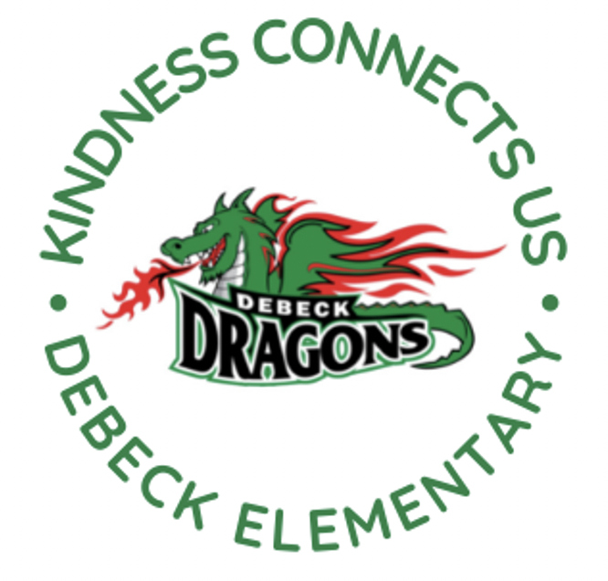
DeBeck Elementary School
8600 Ash St., Richmond BC V6Y 2S3
P. 604-668-6281 E: DeBeck@sd38.bc.ca
Website: debeck.sd38.bc.ca
Safe Arrival: 604-668-6272

L. Schwartz - Principal
C. Anderson – Vice Principal
________________________________________________________________________________________________________________

Week-At-A-Glance
April 8th-12th, 2024
Highlights For Next Week Include:

Monday | Hot Lunch- Pizza and Booster Juice
Tuesday | Connection Crew- Student Leadership @ Lunch  Fruit and Veggie Delivery (Apples)
Wednesday | Book Club @ Lunch  Intermediate Band @ Lunch
Thursday | Lights out Lunch
Friday | Breakfast Club @ 7:45 AM

SCHOOL NEWS

Community Fridge/Snack Shack
Students are still getting used to the availability of healthy snacks in our Snack Shack Fridge. We continue to educate students about the appropriate time to take snacks from the fridge. We are finding that students with good quality lunches are coming and grabbing snacks multiple times during the day. We don’t want to say “No” because the goal is to reduce the stigma around food insecurity and allow students, when needed, to have access to these snacks throughout the day. But we are running out of snacks because students are taking more than they need.

Save the Date
Our band students will be performing at a school concert on Thursday, May 2nd. There will be an afternoon show for students and an evening concert for all families at 6:00 PM.

Lights Out Lunch
To bring awareness to Earth Day, the Connection Crew (Leadership Team) will be encouraging all classes to participate in “Lights out Lunches” on Thursdays for the month of April.

Seismic Update
We are preparing for the first group of classes to move out to the portable. We are just waiting for final inspections of the portables. The first classes to move out the portable will be division 4, 5, 6 and 8. As soon as we have a confirmed date for the move, we will send out more information.

PAC CORNER
Our PAC has opened up the last term of hot lunches from April to June. Orders can be placed online at http://www.munchalunch.com/schools/debeck.

DISTRICT NEWS
Parent Sessions on Social Media Awareness
In partnership with the Ministry of Education and Childcare, Safer Schools Together is offering parent sessions on social media awareness. These sessions all take place in the evenings from 6:30 – 7:30pm and all parents/caregivers and their children (aged 10 and up) may attend.

The dates: Wednesday, April 10 / Tuesday, April 16

Trainings can be found at this link: (link)

UPCOMING EVENTS

APRIL
15 PAC Hot Lunch: White Spot
18 Class Photos and Panorama
19 Immunization Clinic
19 Cyber Presentation (Grade 6/7s in PM)
22 Earth Day Assembly- Families welcome
23 Fruit and Veggie Delivery (Cucumbers)
24 PAC Snack: Kernels
26 Term 2 Learning Updated (report cards) posted to MyEd.
26 Breakfast Club @ 7:45
29 PAC Hot Lunch- Edo

