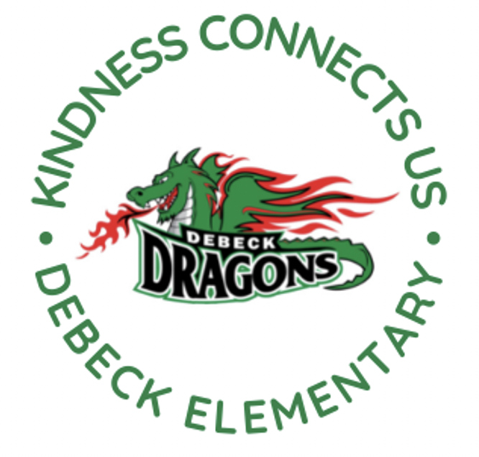
DeBeck Elementary School
8600 Ash St., Richmond BC V6Y 2S3
P. 604-668-6281 E: DeBeck@sd38.bc.ca
Website: debeck.sd38.bc.ca
Safe Arrival: 604-668-6272

L. Schwartz - Principal
C. Anderson – Vice Principal
________________________________________________________________________________________________________________

Week-At-A-Glance
March 11-15th, 2024
Highlights For Next Week Include:

Monday | PAC Hot Lunch: KFC
Tuesday | Gr. 6/7 Boys’ Basketball Practice @ Lunch  Leadership Meeting @ Lunch
Wednesday | Div. 4 and 5 Field Trip- Brighouse Museum and Richmond Library  Intermediate Band @ lunch  Book Club @ Lunch  Grade 6/7 Boys Basketball vs. McKinney (Home game)
Thursday | PAC Recess Snack- Kernels Popcorn  School Spirit Day: Pajama Day
Friday | Spring Break Begins  No School

Congratulations to our Basketball Teams
Our Boys and Girls basketball teams participated in the Palmer tournament this
week. Congratulations on your hard work and sportsmanship. Thank you to
Ms. Chiu and Ms. Greenwell for their leadership. The boys have one more game next week against McKinney.

Term 2 Learning Update (Report Cards)-
In past years, Term 2 report cards have been sent home just before Spring Break. This year, the Richmond School District will be sending home report cards later in April. This will help create a balanced year for reporting as it extends term 2, which has been quite short in the past. Report Cards will go home to DeBeck families on Friday, April 26th this year.

Band/Music Program
Ms. Abrams says hello and wants to assure everyone that she is doing well. She hopes to be back in May. Mr. Smith (Tue/Thu) and Ms. Green (Mon/Wed) will continue to provide music and band programming to our students until further notice.

Screen Time and Internet Safety-
Spring Break is coming and that often leads to increased screen time for kids. Please consider the following:
- Create consistent screen time limits.
- Keep bedtime, mealtime and family time screen free.
- If your child(ren) have social media accounts, monitor what they are posting.
- Have ongoing conversations about being a good digital citizen.
Here is an article for your to consider, “What Does Too Much Screen Time Do to Children’s Brains?”

PARKING LOT SAFETY
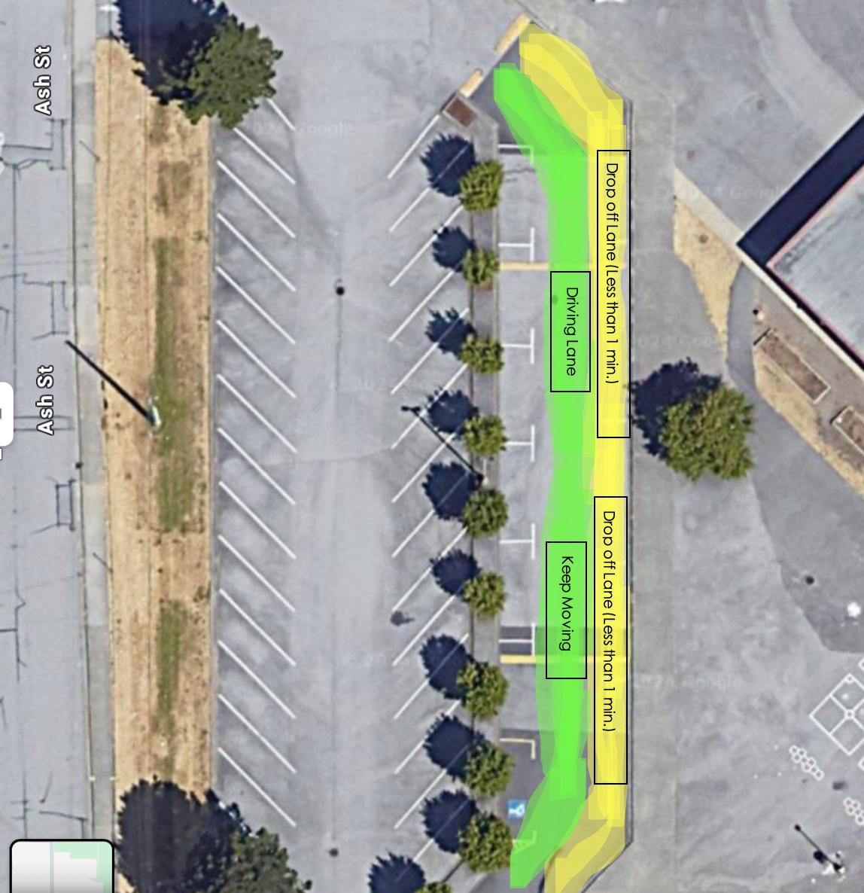

Thank you for your support in making our parking lot safe. We have had considerably less traffic issues in the morning. We will be out next week to continue to remind families of our expectations at drop off:

- Please pull up as far as possible in the drop off lane when coming to school in the mornings.
- Street parking is available on Ash Street and Dayton Avenue
- The drop off lane is for drop off only. You should be parked there for less than a minute (Do NOT leave your car in the drop off zone). After dropping off, leave the area immediately.
- The drive-thru lane is for driving thru, do not drop your child off. This is not a safe place for drop off.

To reduce traffic, consider dropping your child off early or walking to school.

Seismic Update-
The Unitech crew continue to prep the portables for occupancy. The portables should be ready after spring break. We just received information that permits have been received. The phasing plans will be looked at and revised with updated timelines. More information about moving into portables and phase timelines to come after spring break.

PAC Corner-
Krispy Kreme Fundraiser- Our grade 7 committee will be selling Krispy Kreme donuts on Thursday, March 14th after school. First come, first serve. All money raise supports year-end activities for our grade 7s. Thank you for your support.

DATE | LUNCH THEME | ORDER BY
Mon, Apr 08, 2024 | Pizza/Booster Juice | Sun, Mar 31, 2024 11:59 PM
Mon, Apr 15, 2024 | White Spot | Sun, Apr 07, 2024 11:59 PM
Wed, Apr 24, 2024 | Kernels Popcorn | Sun, Mar 31, 2024 11:59 PM
Mon, Apr 29, 2024 | Edo | Sun, Apr 21, 2024 11:59 PM
Mon, May 06, 2024 | Taco Luis/Booster Juice | Sun, Apr 28, 2024 11:59 PM
Mon, May 13, 2024 | Pizza/Booster Juice | Sun, May 05, 2024 11:59 PM
Wed, May 22, 2024 | Kernels Popcorn | Sun, Apr 28, 2024 11:59 PM
Mon, May 27, 2024 | Sushi Lovers | Sun, May 19, 2024 11:59 PM
Mon, Jun 10, 2024 | Pizza/Booster Juice | Sun, Jun 02, 2024 11:59 PM
Mon, Jun 17, 2024 | Edo | Sun, Jun 09, 2024 11:59 PM
Mon, Jun 24, 2024 | KFC | Sun, Jun 16, 2024 11:59 PM

DISTRICT NEWS
Summer Learning 2024 general information- Come join our fun and engaging summer learning programs where you can explore new interests, learn new skills, review, or preview academic courses or complete a full credit course. Registration begins in April for most courses. Click here for more information.

PAC CORNER
With Spring Break starting next week, our PAC has opened up the last term of hot lunches from April to June. Place your orders by the end of March to ensure your children are included for April 8th. Orders can be placed online at http://www.munchalunch.com/schools/debeck.

UPCOMING EVENTS

Mar. 15-April 1 Spring Break- School Not in Session

APRIL
2 First day back after Spring Break
8 PAC Hot Lunch: Pizza/Booster Juice
9 Fruit and Veggie Delivery (Apples)
12 Breakfast Club
15 PAC Hot Lunch: White Spot
18 Class Photos and Panorama
19 Cyber Presentation (Grade 6/7s in PM)
23 Fruit and Veggie Delivery (Cucumbers)
24 PAC Snack: Kernels
26 Term 2 Learning Updated (report cards) posted to MyEd
29 PAC Hot Lunch- Edo

