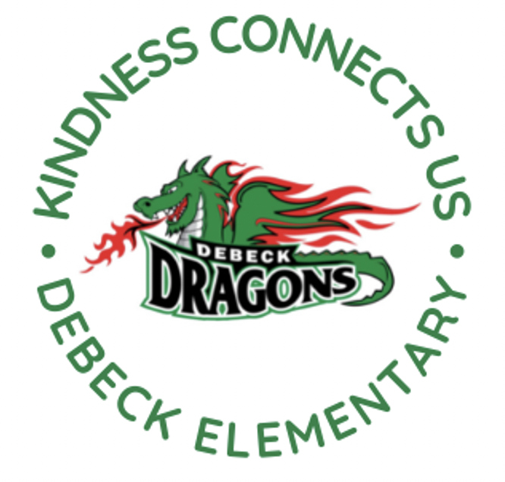
DeBeck Elementary School
8600 Ash St., Richmond BC V6Y 2S3
P. 604-668-6281 E: DeBeck@sd38.bc.ca
Website: debeck.sd38.bc.ca
Safe Arrival: 604-668-6272

L. Schwartz - Principal
C. Anderson – Vice Principal
________________________________________________________________________________________________________________

Week-At-A-Glance
Feb. 12th- Feb. 16th, 2024
Highlights For Next Week Include:

Monday | PAC Hot Lunch- Sushi Lovers
Tuesday | Fruit and Veggie Delivery (Snap peas)  Leadership (Connection Crew) @12:10 in the library  Gr. 6/7 Girls’ Basketball Practice @ 8:00 AM  Gr. 6/7 Boys’ Basketball Practice @ Lunch
Wednesday | Book Club at Lunch  Intermediate Band at Lunch  Early Dismissal for Conferences @ 1:45PM
Thursday | Girls Basketball practice at Lunch  Early Dismissal @ 1:45 PM for Conferences
Friday | Professional Learning Day- No School for Students  No Breakfast Club this week

SCHOOL NEWS

Breakfast Club-
Our Breakfast Club schedule until Spring Break is:
February 23rd
March 1st and 8th

Spirit Days-
Our Student Leadership/Connection Crew are planning some upcoming Spirit Days for everyone.
Wed. Feb 28th- Pink Shirt Day
Fri. Mar. 1st- Sports Team/Sports Wear
Fri. Mar. 8th- Decades Day- Come dressed in clothes from the 80s, 90s or 2000s
Thu. Mar. 14th- PJ Day

Scholastic Book Fair- Book Fair
We are excited to share that the Winter Book Fair is coming to DeBeck. Students will be given an opportunity to browse and an opportunity to buy during class time. There will also be Family book fair times:
Mon. Feb. 26th- 2:45-3:15 PM
Tue. Feb. 27th- 8:15-8:35 AM and 2:45-3:15 PM
Wed. Feb. 28th- 2:45-3:15 PM
Thu. Feb. 29th- 8:15-8:35 AM
Thank you, Ms. Borthwick for bringing the Book Fair to DeBeck. All monies raised goes back into the library and supports getting good quality books into the hands of our students.
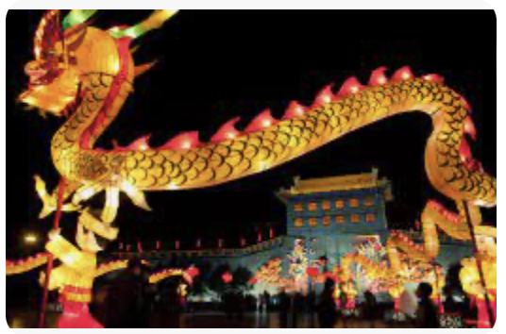
Lunar New Year- The first day after the new moon is celebrated at Lunar New Year, a religious and cultural festival for Chinese, Vietnamese and Koreans of Buddhist and other backgrounds. This year is the Year of the Dragon. The dragon is considered a symbol of strength, courage, and good fortune. Gung hay fat choy to all our DeBeck families who celebrate this holiday!
Black History Month- In February, people across Canada participate in Black History Month events and festivities that honour the legacy of Black people in Canada and their communities. The 2024 theme for Black History Month is: “A Heritage to Celebrate; A Future to Build”. This theme represents both an opportunity to talk and learn more about the stories of Black communities in Canada and their histories, successes, sacrifices and triumphs. No matter where you live, we invite all Canadians to learn more about these communities, and how they continue to help shape Canadian history.
Seismic Update- The Seismic crew continue to prep the portables for occupancy at the end of February. As you likely have noticed, digging has begun on school grounds to connect power to the portables and the future day care site.
DISTRICT NEWS
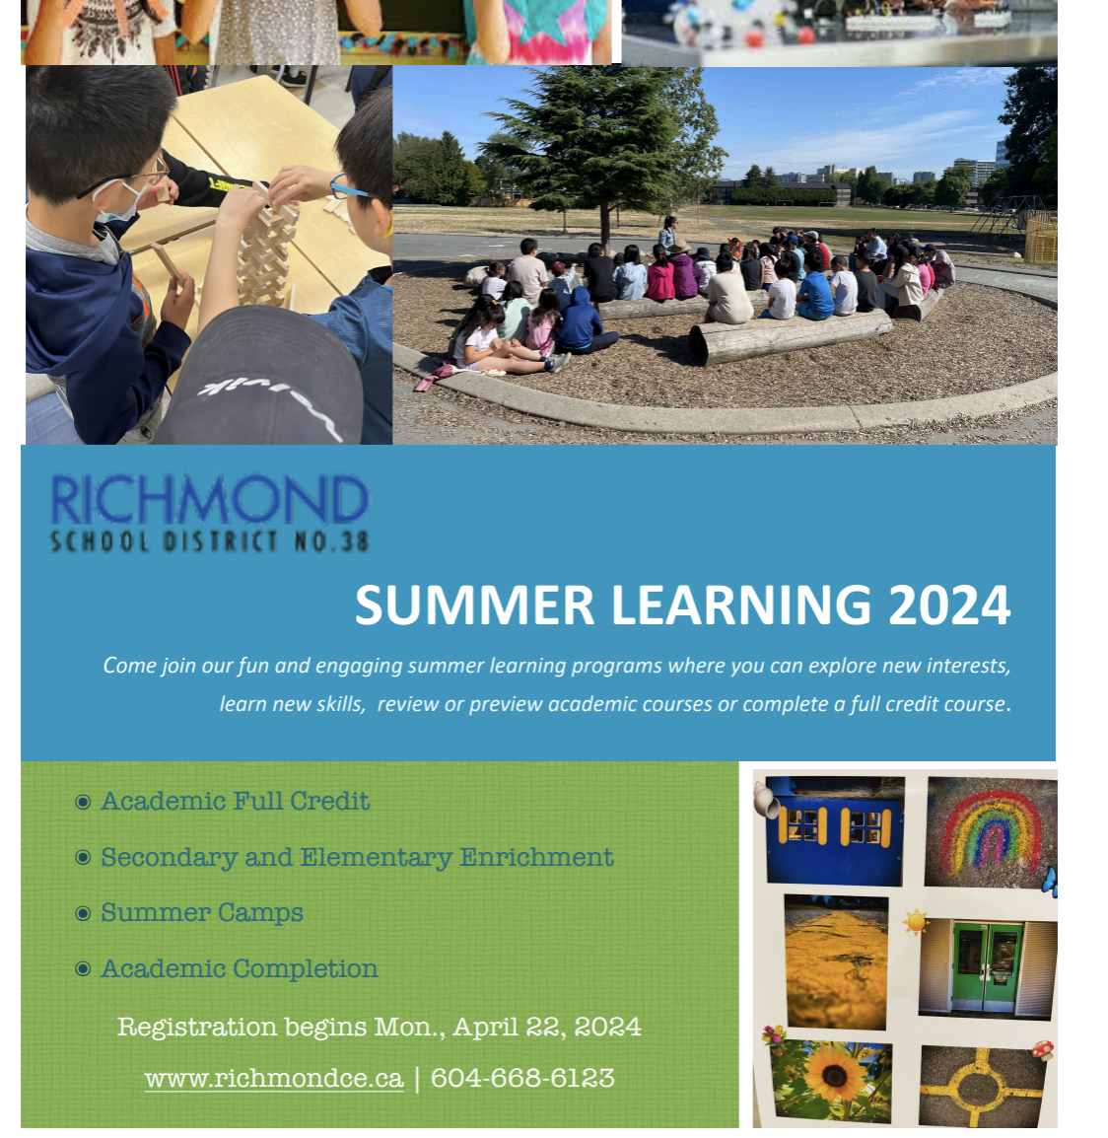
Summer Learning 2024 general information- Come join our fun and engaging summer learning programs where you can explore new interests, learn new skills, review, or preview academic courses or complete a full credit course. Registration begins in April for most courses. Click here for more information.

Social Media Awareness Session-Safer Schools Together, in partnership with the Ministry of Education and Childcare, is offering “Social Media Awareness” family sessions. These sessions are designed to support families and caregivers navigate the digital world. Dates, times and information to register can be found in the link below:
https://pages.saferschoolstogether.com/erase-family-session
PAC CORNER
Order Hot Lunch online here Munchalunch.com for the winter session!
DeBeck Hot Lunch Dates (Winter 2024)
DATE FOOD DEADLINE
Mon. Feb. 26 | Taco Luis | Sun. Feb. 28th @ 11:59 PM
Mon., March 4 | Fusion Feast Pizza/Booster Juice | Sun Feb 25, 11:59pm
Mon., March 11 | KFC | Sun Mar 3, 11:59pm
Thur. March 14 | Kernels popcorn (snack at recess) | Sun Feb 18, 11:59pm
​Please note that popcorn has an ordering deadline of 3 weeks prior, unlike the other lunches (1 week).
UPCOMING EVENTS

FEBRUARY
18 Deadline to order Kernels popcorn (March 14th delivery)
19 Family Day (No School)
21 PAC Recess Snack- Kernels Popcorn
21 Division 1 Field Trip- Richmond Children’s Festival
21 Gr. 6/7 Boys Basketball @ Maple Lane (parent drivers needed)
22 Gr. 6/7 Girls Basketball vs Maple Lane (Home game)
22 Gr. 6/7 Boys Basketball @ McKinney (parent drivers needed)
23 Breakfast Club @ 7:45 AM
26 PAC Hot Lunch- Taco Luis
26-29 Scholastic Book Fair
28 Pink Shirt Day- Assembly @ 9:10 AM

MARCH
4 PAC Hot Lunch- Pizza and Booster Juice
6 Div. 6 and 7 Field Trip- Brighouse Museum and Library
6, 7 Palmer Feeder School- Grade 7 Basketball Tournament
7 PAC Meeting @ 6:30 PM on Zoom
11 PAC Hot Lunch KFC
13 Div. 4 and 5 Field Trip- Brighouse Museum and Library
13 Gr. 6/7 Girls Basketball @ Wowk (Parent Drivers needed)
13 Grade 6/7 Boys Basketball vs. McKinney (Home game)
14 PAC Recess Snack- Kernels Popcorn
14 Spirit Day- Pajama Day
14 Last day before Spring Break
Mar. 15-April 1 Spring Break

APRIL
2 First day back after Spring Break

