Monday | Tuesday | Wednesday | Thursday | Friday
HAT DAY  OR  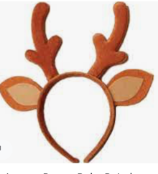  HOLIDAY HATS  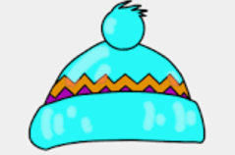  Do you have a favourite baseball cap, toque, or holiday hat that you can’t wait to show off? Don’t forget those reindeer antlers or elf ears. We can’t wait to see your gear. | WACKY HAIR DAY  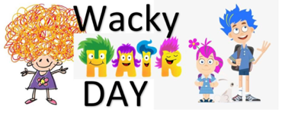  Spiked hair, coloured hair, hair that goes up, hair that goes down. What will you do to your hair to make it WACKY? | PJ DAY  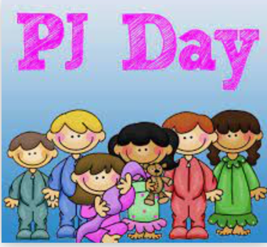  Let’s have a comfy, casual day. Wear your PJ’s or your favourite sweatsuit. If you choose to wear slippers, please remember your inside shoes.. | TWIN DAY/ DUPLICATE DAY  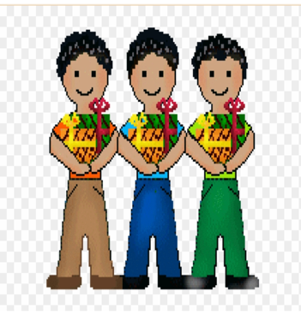  Choose a friend or two or three or your whole class. Dress the same. Match those clothes and duplicate those colours. | WINTER WEAR (Comfy, Cozy day)  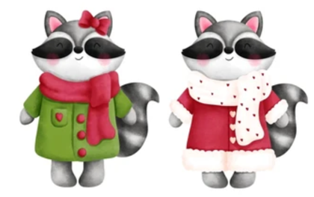  It is the last day before the winter break. Let’s dress cozy. Wear your coziest sweats, your warmest fleece and let’s have a wonderful last day together.

